AUDICS

A MINI PROJECT REPORT
Submitted by

Piyush Sunil Patil
(PRN-1921321246041)
Pranav Avinash Malshikhare
(PRN-1921321246042)

THIRD YEAR
BACHELOR OF TECHNOLOGY
In
INFORMATION TECHNOLOGY

Guided By
Mr. Y. R. Tayade

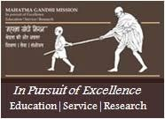

Department of Information Technology

MGM’s Jawaharlal Nehru Engineering College, Aurangabad
YEAR 2021-22

CERTIFICATE

This is to certify that the mini project report

AUDICS
Submitted by
Piyush Sunil Patil 1921321246041
Pranav Avinash Malshikhare 1921321246042

is a bonafide out carried out by them under the supervision of Prof. Y.R.Tayade and it is approved for the fulfillment for curriculum mini project in third year of B.Tech. Information Technology, from Dr. Babasaheb Ambedkar Technological University, Lonere.

Date:

Prof. Y. R. Tayade Dr. S. C. Tamane
Guide Head of Department
Dept. of Information Technology Dept. of Information Technology

Dr. H. H. Shinde
Principal
MGM’s Jawaharlal Nehru Engineering College, Aurangabad

CONTENTS
List of Abbreviation i
List of Figures i
List of Tables i
Abstract ii
Content | Page No.
- INTRODUCTION | 1
- Introduction | 1
- Necessity | 1
- Scope | 1
- Objectives | 1
- LITERATURE SURVEY | 2
- PROBLEM DEFINITIONS AND SRS | 3
- Problem Statement | 3
- Objectives | 3
- Major Inputs and output | 3
3.4 Hardware Resources Required | 4
3.5 Software Resources Required | 4
- SYSTEM DESIGN | 5
- Proposed System Architecture | 5
4.1.1 Working of music player | 5
4.1.2 Working of audio book | 6
- RESULTS AND PERFORMANCE ANALYSIS | 7
5.1 Libraries use | 7
5.2 Program input and output | 8
5.3 Algorithm | 9
- Conclusion | 10
- References | 11

List of Abbreviation
UI – User Interface
GUI – Graphical User Interface
IDE – Integrated Development Environment

List of Figures
- System architecture of music player
- System architecture of audio book
- Program Input/Output

List of Tables
1.Literature Review

Abstract
Audicx is the application made with the combination of music book and audio book. It is used to run songs with the help of python libraries and using tkinter .Audio is an important source of communication and is just as important today as text. We know that audio files are digital files. So you need a tool to run the digital files, or in other words to play the files. Without this tool or player, we can never listen to music, movies or the contents of an audio file. So we need music players. This device is used to play music and other digital audio files. It also helps to take the files as a document and read the files for us as a whole file page by page so that the people who are fond of listening and the persons who are not able to see properly can be benefitted with the help of the application. Other applications only have either music player or audio book. In this application the combination of both is made. The music player GUI project idea tries to emulate the physical music player. This program allows you to play songs, music and all music files with the audio book inbuilded with it on your desktop or laptop. Using Python is a basic programming application built using the Python programming language.It is a GUI program created using the Python Tkinter pygame libraries.

.

- INTRODUCTION
1.1 Introduction -
We need an application that will allow us to play or listen to digital audio files. The music player is the device for playing MP3. And we are designing an audio book which will read a pdf or a word file of any particular book. By developing the audio book we will help the people who are handicapped and cannot able to see this beautiful world. Music Player is developed to listen the music with an excellent UI design created by us. We can load songs of our interests and play them accordingly as per the choice of the user. Python has libraries that can play audio files, such as: B. Pygame, which allows you to work with media files in just a few lines of code.

1.2 Necessity –
This system is build for users so that they can listen the music in offline mode rather than listening the songs in online mode. The system comes with added feature of audio book. The user can listen music as well as if he wishes to read an book we have that additional feature of providing the audio ai in the system . The system will automatically read each and every line of the given pdf . And the user can visit any page of its interest.
1.3 Scope -
It plays the music by scanning the required playlist. Also it reads the books of any kind,any topic. We can redirect to any of the system as per our requirements.
1.4 Objectives -
- Helps people to listen music of their interest.
- Helps handicapped people to listen the book which they could n’t see.
- Helps people to refresh their mood.
- This system helps to play offline songs into its application.
- To provide a secure platform to the user through the system.
- Helps user to handle this system with clear idea
- LITERATURE SURVEY

Title of Paper | Author & Publication Year | Abstract | Techniques used | Conclusion
Reprobooktor: A concept of audiobook player for visually impaired older adults. | Barbora Endrstova | This work focuses on entertainment and education  of visually impaired older adults. We present design concept  of a physical device for audio content playback tailored to  specifific needs and preferences of this user group. | Python | In this work, we presented a new device to play audiobooks  and other audio content that is adapted to needs and preferences of older adults with severe vision impairment.
Music Player – Using Python | Mr. Mehraan Khan | Audio is an important source of communication and is just as important today as text. We know that audio files  are digital files. | Python and Algorithm. | The MP3 player is a device for playing and listening to digital audio files, which can be MP3 files or other audio files.

Table 2.1: Literature review

- PROBLEM DEFINITION AND SRS
3.1 Problem Statement :
To create an MP3 player using the Python programming language to play and listen to songs, MP3files, and other digital audio files. The player must have a simple and easy-to-use interface with options for various functions and a screen around the entire playlist and buttons to turn off the player. The player should be able to play any song. It must be able to play MP3 files or other digital audio files. It should give the user the option to pause or resume the song. the user should be given basic details about the song being played. To create audio book according to the requirement of user.

3.2 Objectives:
- Aim is to develop a system using Python
- To play various songs in one click
- Providing good UI so that the user can use the application easily
- Helps the user to refresh their mood accordingly by playing new songs
- Designing two way system into a system which helps in proper interaction.
- Helps user to handle the system with clear idea.

3.3 Major Inputs and Output:
Just provide the folder where the songs are present and simply the library of songs will be displayed accordingly. To run the audio book just input the pdf or any readable file and press the read icon.
- UI for accessing the data remotely.
- Mobile app for uploading of data.
- Chat Bot for FAQs of students.
- Service Provided.
- Service platforms.

3.4 Hardware Resources Required:
- Processor – i3 / Ryzen 3
- Hard Disk: 1 TB
- RAM – 2 GB
- Any internet Connection
- Computer system / Laptop

3.5 Software Resources Requirement:
- Operating System: Windows ,Linux
- PYTHON IDE
- VS CODE STUDIOS
- Browser: Any
- Images of UI
- Open Weather Map Api

- SYSTEM DESIGN

4.1 Proposed system architecture

4.1.1 Working of Music Player
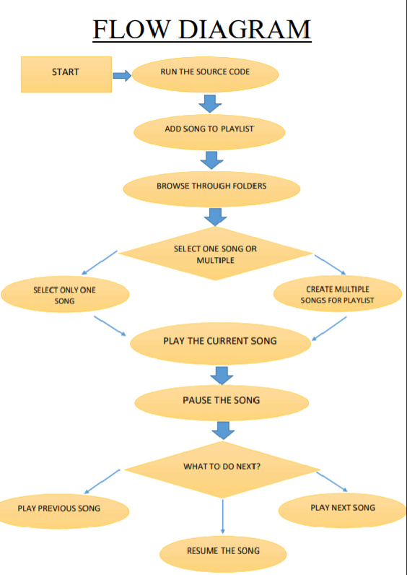

4.1.2 Working of audio book

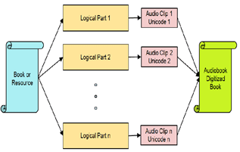
Step 1:
The user will launch the application and then load the playlist of interest by browsing through the device it is running on.

Step 2: The input of user will fetch the playlist and load the songs and play it as per instructions

Step 3:
If the user wants to redirect to the audio book , simply can press the button placed which will automatically call the application.
Step 4:
The user can simply enter the document of its choice and the rest will be taken care by the program by converting the words into audio.

Step 5:
If all the instructions are given properly by the user then the application will work fine without
errors.

- Result and Performance Analysis

5.1 Libraries Used
a. Tkinter:
We already told you in the title of this page that we will be using the Tkinter library, a standard library for GUI creation. The Tkinter library is the most popular and easiest to use and contains many widgets (these widgets help create attractive GUI applications). Also, Tkinter is a very lightweight module and useful for building cross-platform applications (so the same code can be easily used on Windows, macOS, and Linux.

b. Pygame module:
Pygame is a Python module that works with computer graphics and sound libraries and designed with the power of playing with different multimedia formats like audio, video, etc.

c. OS module:
There is no need to explicitly install this module as it comes with the standard Python library. This module offers various functions for interacting with the operating system. In this tutorial we will use the OS module to get the song playlist. from the specified directory and make it available to the music player application.

5.2 Program input and output
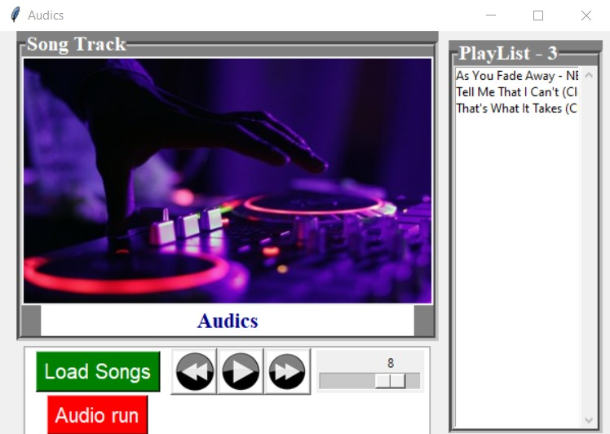

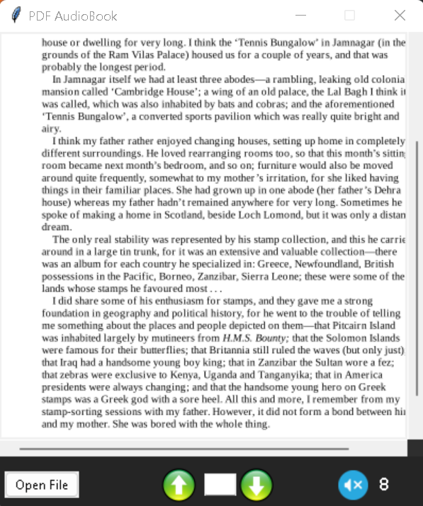
5.3 ALGORITHM
1. Import the libraries.
2. Create an object of the tkinter and Pygame libraries.
3. Create a window using Tkinter object.
4. Add buttons that provide different functionalities.
• Add a song
• Play the song
• Pause the song
• Play previous song
• Play next song. Add a song button when pressed should open a dialog box to browse and choose the file.
6. Add label to display the song’s information.
• Name
• Singer
• Duration
• Size of the file, etc.
7. Display screen will display the details of the entire playlist.
8. Close button will automatically clear the song list and will stop playing.

6.CONCLUSION
We successfully designed the system which can run music as well as translate words of documents into audio. The application is working well and navigation to audio book is also done if necessary. The work of app is perfectly done.

7.References
[1]. Matthew E. P. Davies, Philippe Hamel, Kazuyoshi Yoshii, and Masataka, “Automatic Creation of Multi-Song Music Mashups” ,IEEE/ACM transactions on audio, speech, and language processing, vol. 22, no. 12, December 2014
[2]. Sushmita G. Kamble ; A. H. Kulkarni, “IEEE/ACM transactions on audio, speech, and language processing”, vol. 22, no. 12,December 2014 2016 International Conference on Advances in Computing, Communications and Informatics (ICACCI)
[3]. Karthik Subramanian Nathan ; Manasi Arun ; Megala S Kannan 2017 IEEE International Symposium on Signal Processingand Information Technology (ISSPIT)
[4]. E. Bouchard Ryan, A. P. Anas, M. Beamer, and S. Bajorek, “Coping with age-related vision loss in everyday reading activities,” Educational
Gerontology, vol. 29, no. 1, pp. 37–54, 2003.
[5] S. A. Stevelink, E. M. Malcolm, and N. T. Fear, “Visual impairment, coping strategies and impact on daily life: a qualitative study among working-age uk ex-service personnel,” BMC public health, vol. 15, no. 1,
p. 1118, 2015.

